All About China
What is the capital of China?
__________________________________________________________
What is the population of China?
__________________________________________________________

The tallest mountain in the world is on China’s border.
- What is the mountain called?
________________________________________________________
- What is the other country that the mountain shares the border with?
________________________________________________________
Name one major river that flows through China.
__________________________________________________________

Write an interesting fact about China that you didn’t know.
__________________________________________________________
__________________________________________________________

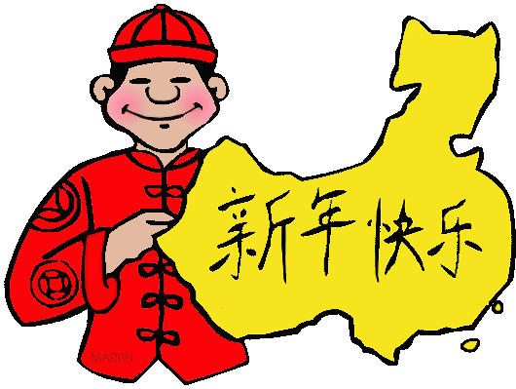
Draw the Chinese flag.

